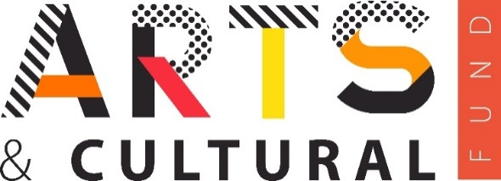
Date: 13.06.22
Press release: 044
Release date: Immediate

Essex County Council Arts and Cultural Fund projects to launch this summer

A host of arts and cultural events and projects are to take place across the county this summer due to the Essex County Council Arts and Cultural Fund which will provide over £1 million in funding over five years to help support the creative sector.

ESSEX residents are to set to enjoy a range of arts and cultural events taking place across the county this summer following the announcement of successful applications to the Essex County Council Arts and Cultural Fund.

Launched in January 2022, the Arts and Cultural Fund – which will provide over £1 million in funding over five years to help support the cultural and creative sector and is part of Essex County Council’s (ECC) Everyone’s Essex strategy - was open to small and large organisations, grassroots community groups, charities and start-ups as well as many more.

Following its launch, the Arts and Cultural Fund received over 200 applications. Over 40 applications were successful and are to receive - dependent upon the size and nature of the project - between £2,500 to £25,000 in funding.

The successful applications cover a range of disciplines within the arts and cultural sector, including community activities, music, dance, theatre, photography, workshops and both digital and non-digital events.

Many of the successful applications were approved due to how the projects will meaningfully engage with communities throughout Essex. A number of projects are designed to support economic regeneration, help alleviate mental and physical health issues, and highlight the importance of climate change action to the county’s residents.

Many of the projects will tour the county and support those in both rural and urban areas who feel isolated and vulnerable, while also working with ethnic minority artists and creative groups to help support the county’s diverse and vibrant communities.

Councillor Graham Butland, Essex County Council Cabinet Member for Devolution, the Arts Heritage and Culture, said: “To have received and approved so many applications of such high-quality is testament to the fantastic and highly skilled members of the creative sector that we have right here in Essex.

“The Arts and Cultural Fund is extremely important in helping and supporting the creative sector following the pandemic and I am delighted that these exciting projects, which cover a wide range of artistic and cultural disciplines, will be launched over the coming months. Be it from countryside to coast, these projects will enrich the lives of the county’s residents.”

To view the successful projects and for more information about the Arts and Cultural Fund visit: www.explore-essex.com/essex-acf-2022.

-Ends-

Notes for editors:
For more information contact: Emma Williams, Marketing and Communications Lead, Emma.Williams@essex.gov.uk or Christopher Davies, Marketing and Communications Officer, Christopher.Davies@Essex.gov.uk or telephone 07738 885659.

Explore Essex: Explore Essex brings together a unique group of Country Parks and heritage venues which are owned by Essex County Council. Its mission is to deliver a broad range of exciting facilities and activities for the people of Essex with an emphasis on culture, heritage and environment. www.explore-essex.com @exploressex @exploreessex.

