For iPhone
iPhone (should) have a voice recorder app already installed on the device.
To record:
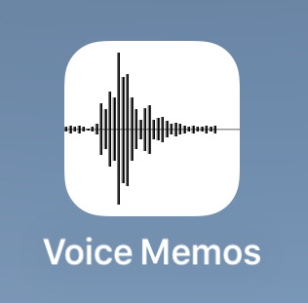 Open the Voice Memos app
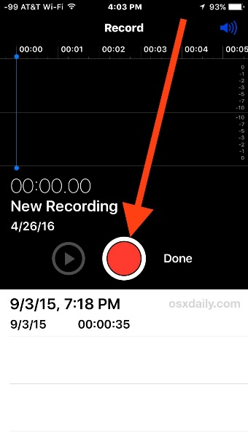 Tap/hit the Red Record button
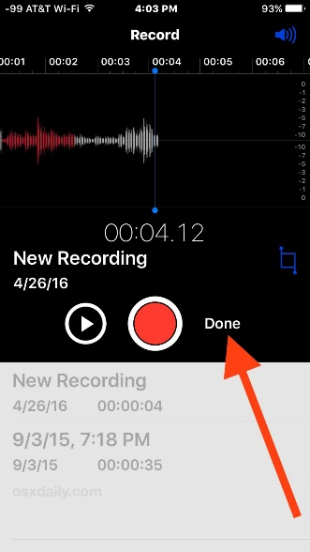 Tap/hit done when finished recording
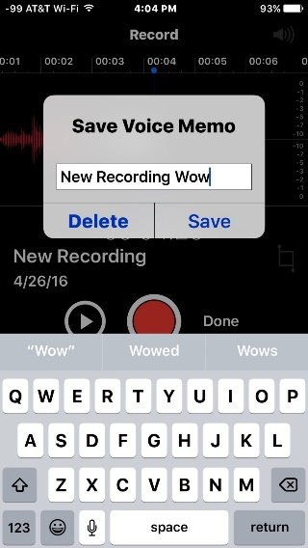 Save the voice recording and give it a name
Back in the Voice Memos app on iPhone, tap to select on the voice recording you want to share. Tap the sharing button, it looks like a box with an arrow flying out of the top
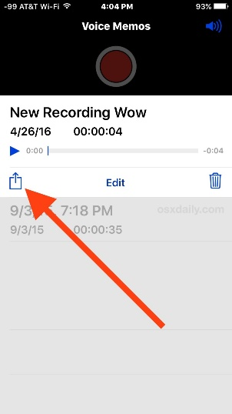
Choose the method which you want to share the voice recording with; Message, Mail, Add to Notes, or a third-party app of your choice (i.e. Facebook)
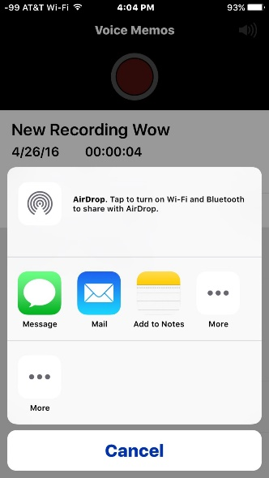

For Android phones
The following app will allow people to download it and record like a Dictaphone: https://play.google.com/store/apps/details?id=com.media.bestrecorder.audiorecorder&hl=en_GB

